**Dexta Robotics Announces Force Feedback Gloves Dexmo Enterprise Edition, Radically Improving the Quality of Virtual Training**

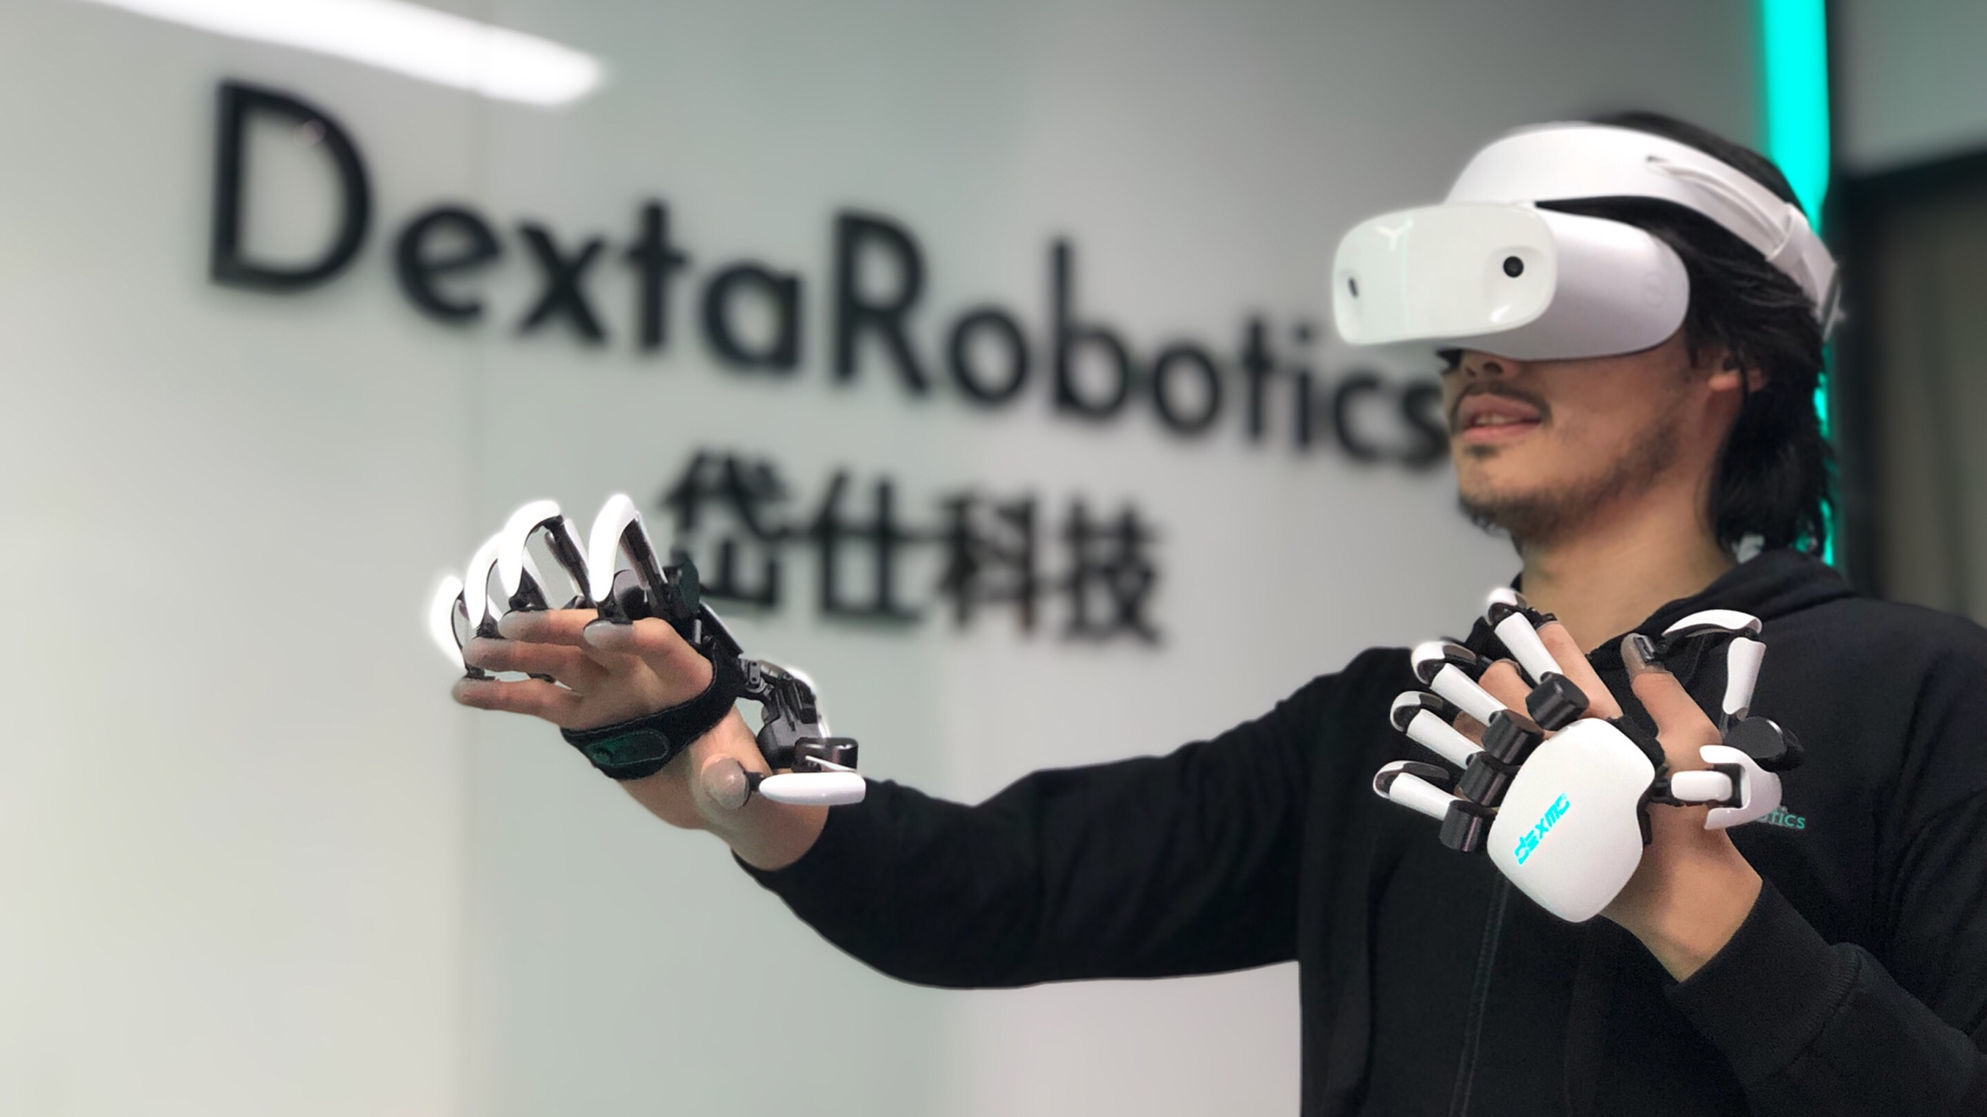

Dexta Robotics unveiled its force feedback glove prototype in 2014. After more than 50 iterations, Dexta Robotics is officially launching Dexmo Enterprise Edition - the world’s first wireless force feedback gloves that integrate both motion capture and force feedback capacities. It enables people to perform real-life actions with their full-hand dexterity in virtual world. They can feel the size, shape and stiffness of virtual objects, marking one step closer to full-immersion in VR, and radically improve the quality of virtual training.

With Dexmo, users will be able to realistically feel the sensation of flipping a switch, pressing a button or turning a knob, and other complex hand interactions.

After the small batch distribution of Dexmo DK1 in 2017, Dexta Robotics gathered many feedback from early adopters and had its manufacturability, hardware stability, core functionality, ergonomics and software support upgraded in every aspect. The company is now mass-manufacturing Dexmo Enterprise Edition, and the product may be directly ordered at Dexta Robotics’ website ([www.dextarobotics.com](http://www.dextarobotics.com))today.

***How Dexmo is made:*** [***https://youtu.be/ICEyBUJj3_4***](https://youtu.be/ICEyBUJj3_4)

“Today’s VR/MR devices can offer immersive visual and audio experiences. However, we are still far from complete immersion. A critical missing part is the lack of true force feedback technologies capable of providing users with real touch sensation. Existing methods mostly rely on vibration motors to simulate haptic feedback. They do not hinder finger movements. Therefore users do not perceive a real physical force, which is very different to reality,” said Dexta Robotics’ Technical Adviser, Dr. Per Ola Kristensson, who leads the Intelligent Interactive Systems group at the University of Cambridge.

”With the Dexmo force-feedback glove, users can feel the virtual world with their own hands which undoubtedly improves immersion，” he concluded.

But how does it work exactly? “Its rotational sensors read hand movement and regenerate a detailed virtual hand model to keep it in perfect sync with the user’s hand motion, allowing users to use their hands virtually. When interacting with virtual objects, our interaction engine computes the magnitude and vector of force and the force-feedback units apply force to user’s fingertips, which imitates the push-back you’d get from real objects. People can extend their touch sensation from the real world into the virtual world simply by putting Dexmo on. For example, when you turn a faucet you can feel its round shape, even the drops of water on your finger,” explained by Juxue Tang, Dexta Robotics’ product engineer.

To the general public, using current button/ joystick-based controller still needs learning and adaptation, however everybody knows how to use their hands. Dexmo offers the most intuitive solution: by transducing virtual hand behavior, it lower users’ learning cost significantly, and greatly improve the immersive experience.

“Smartphones’ development was slow in the early days. The true era of smartphone came after iPhone and its revolutionary multi-touch interaction technology. It was so intuitive that even a five-year-old can operate without reading a manual. Current VR is comparable to the early stages of smartphones, where products are functional, but not user friendly enough. To help it go mainstream, we try our best to create an interaction system that is ‘stupid easy’,” said Aler Gu, founder and CEO of Dexta Robotics. “We eventually arrived at a dual-hand, highly immersive, low learning cost and lightweight portable force feedback glove Dexmo. We successfully packed five motors, 11 rotational sensors, a rechargeable battery, and a set of control systems into a unified body that weights only 290g and works wirelessly. This is a groundbreaking product in the interaction technology history.”

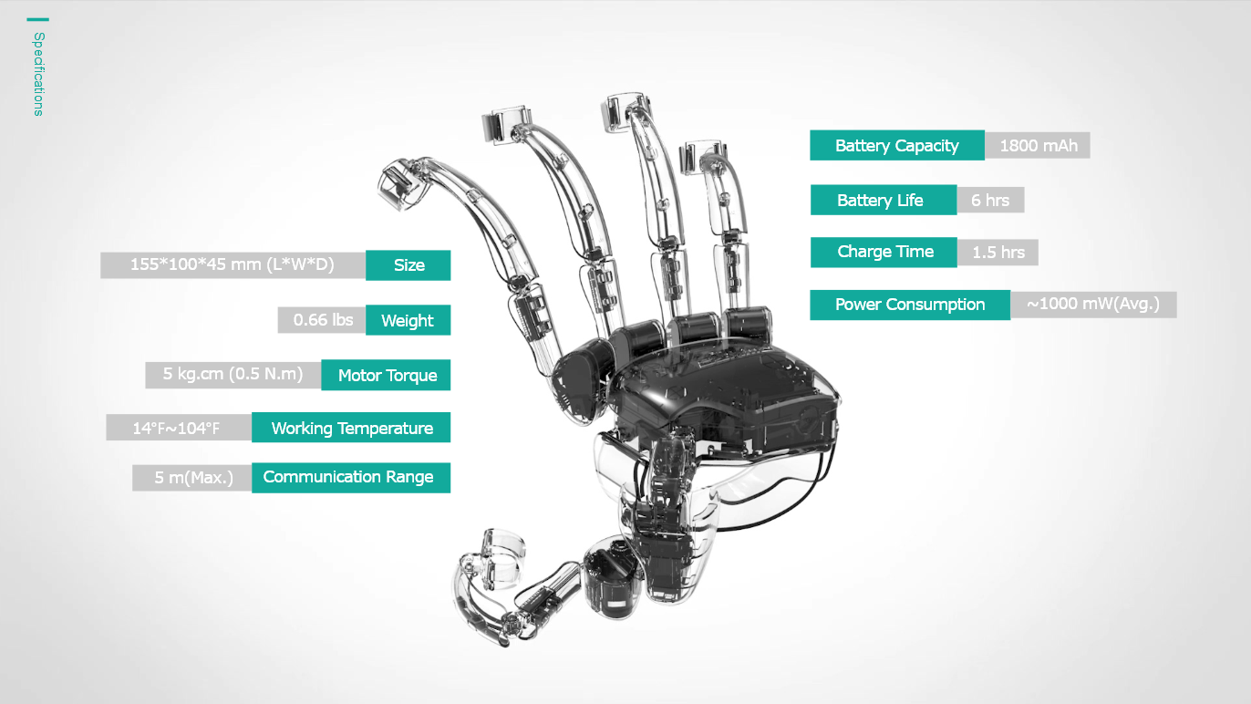

Dexmo comes with a very useful SDK support. Thanks to the feedback from the early adopters provide, many enhancements have been made to ensure that even people with limited VR knowledge can follow its detailed step by step instructions to explore possible applications of Dexmo. The SDK supports all mainstream VR/MR headsets and tracking system. After some simple setup, the hand model and its orientation would appear. The SDK has preset interaction modules such as press, twist, and grab. By simply selecting the pre-sets, adding scripts, and setting script parameters, basic interactions can be set. Then user can continue to define the feedback caused by the interactions and material changes based on the development document Dexta Robotics provides. Scenarios with multiple interaction samples are also included to help user take full advantage of the development document.

Dexmo can be of great use to many industries, including aerospace, vocational simulations, education, gaming, medical training, tele-operation. It already has a broad base of use cases such as: electrical car battery maintenance training, assembly line working training, flight simulation, cabin group vocational training, power plant/ nuclear power station training, interactive education, large space gaming, medical rehab, humanoid robot tele-operation etc.

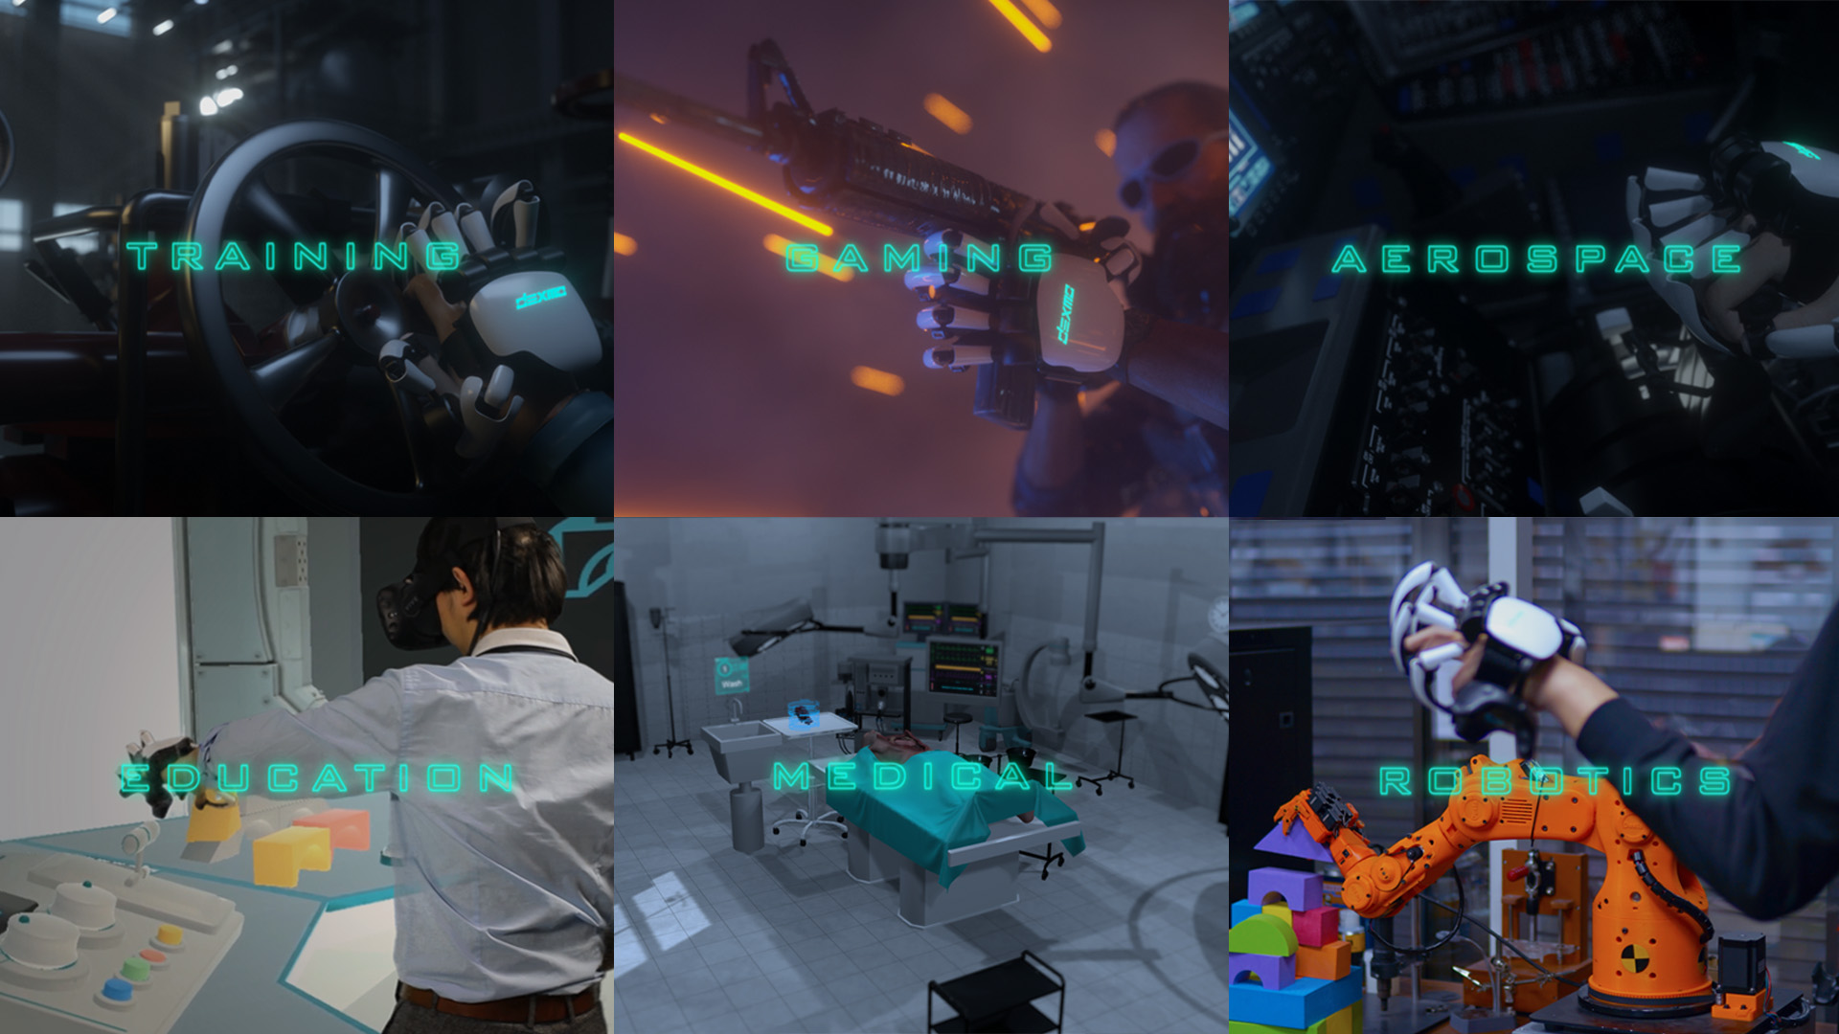

Dexta Robotics is currently partnering with car manufacturers and factory owners to train workers in virtual environment, lower the training cost and improve training result by making hands-on learning more accessible. Parts assembly, quality control, maintenance all have tremendous needs in training. In Dexta Robotics’ current partnership with car manufactures, Dexmo is used to train new workers on how to place cables in cars. Their hand movements are reflected into the virtual space accurately, and the realistic and precise feedback allows workers to feel each component as if they were there, ensuring they really understand the standard before they assemble anything. This drastically reduces costs in factory training and more importantly, provides virtual guidance and feedback, which generates far better training results.

Dexmo can be especially helpful in auto industry given the fact that electric car sales skyrocket. The demand for electric car mechanics and repair will naturally soar. By leveraging Dexmo for efficient and innovative mechanic training, a more effective production and repair process can be achieved.

Dexmo’s application is not limited to just car assembly, it also applies to maintenance, design and much more. For instance, it accelerates the car design process by enabling designers to see and feel their design iterations virtually instead of creating expensive and time-consuming physical prototype.

***Fields of applications of Dexmo:*** ***<https://youtu.be/-tM7AwyHs-s>***

Dexta Robotics aims to accelerate its product and business development in 2019. To allow more people benefit from this new interaction method, the company will need to partner with more industries, explore more possible applications and more capital support. There is still a long way to go, but eventually Dexta Robotics hopes to bring Dexmo to the consumer market. Once Dexmo hits the economies of scale, the company will be able to bring this technology to the general public. To Learn more about Dexmo Enterprise Edition, stop by **Booth #1161 at SIGGRAPH 2019** or visit [www.dextarobotics.com](http://www.dextarobotics.com). You can also find Dexta Robotics on [Facebook](https://facebook.com/dextarobotics) , [Twitter](https://twitter.com/dextarobotics), [Instagram](https://www.instagram.com/dextarobotics) and [YouTube](https://www.youtube.com/channel/UC72fspx0dMe4EnGQJzoa6oA).

**About Dexta Robotics**

Dexta Robotics is a company founded by a group of passionate robotists in 2014. The goal of the company is to use advanced robotics technology to create the next generation of interaction interface for VR/MR and accelerate its the popularization. Dexta Robotics has raised over 10M(CNY) angel round from Grainsvalley Ventures and Sunwoda(A Public company). Its core team members have backgrounds from top-notch universities and industries such as: Cambridge University, Tsinghua University, Microsoft and DJI etc. In 2018, it started to ship its early development kit with full SDK support with all mainstream headsets. Today Dexta Robotics holds more than 30 patents/pending-patents worldwide, and is the world‘s leading designer and manufacturer of interaction system.

**Media Contact**

Marketing Manager: Zelda Zhang

Wechat: zizhangzizi

Phone:+86- 0755-86667094

Email: zeldaz@dextarobotics.com

**Presskit**

Available to download from [press.dextarobotics.com](http://press.dextarobotics.com/),or click below to download

[Dexmo’s product details, functionalities, use cases, related photos, gifs and videos](http://press.dextarobotics.com/)

**Related Videos**

<https://www.youtube.com/channel/UC72fspx0dMe4EnGQJzoa6oA>

**Related Links**

Dexta Robotics website：[https://www.dextarobotics.com](https://www.dextarobotics.com/)

Dexta Robotics Twitter: <https://twitter.com/dextarobotics>

Dexta Robotics Facebook: <https://facebook.com/dextarobotics>

[Dexta Robotics Instagram: <https://www.instagram.com/dextarobotics>](https://www.instagram.com/dextarobotics)